NAME: MORLA MOUNIKA

TEAM LEADER

ASSIGNMENT-2

1.DONUT CHART:

2.AREA CHART:

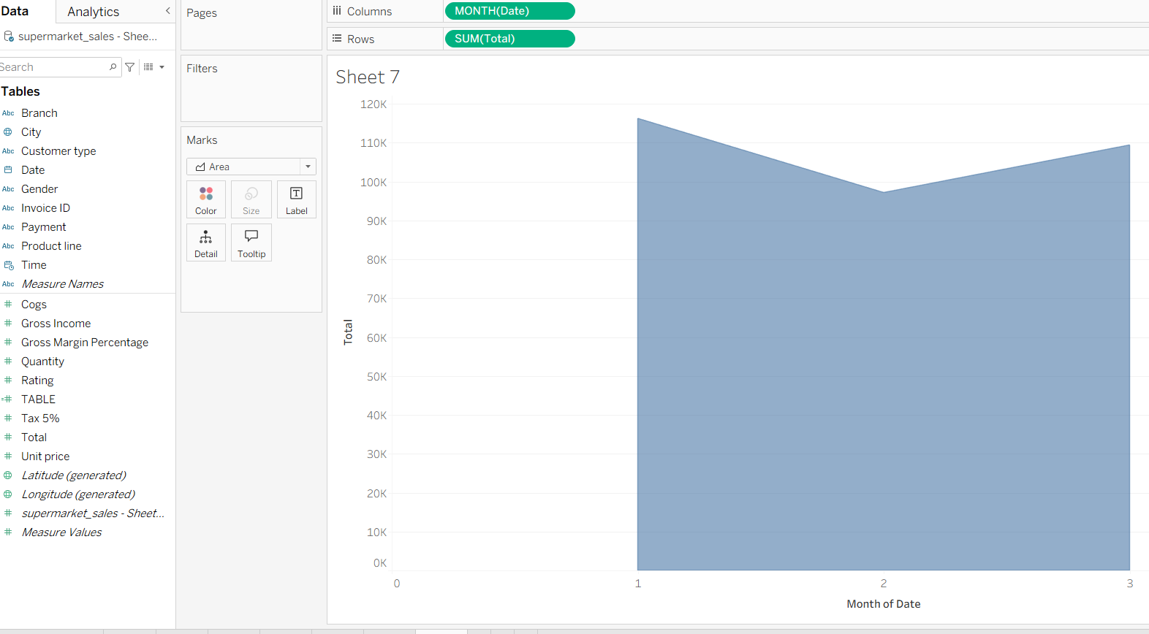

3.TEXT TABLE:

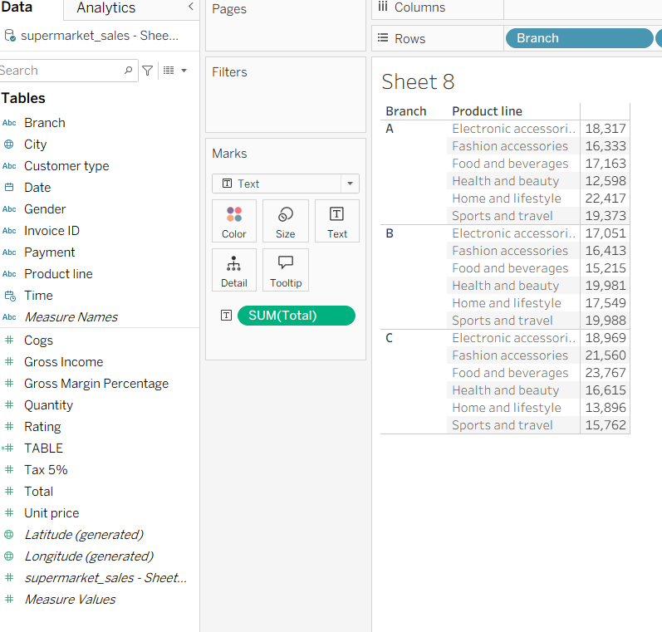

4.HIGHLITED TABLE:

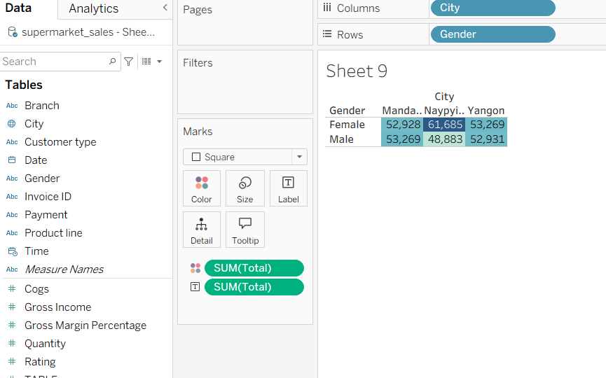

5.WORD CLOUD:

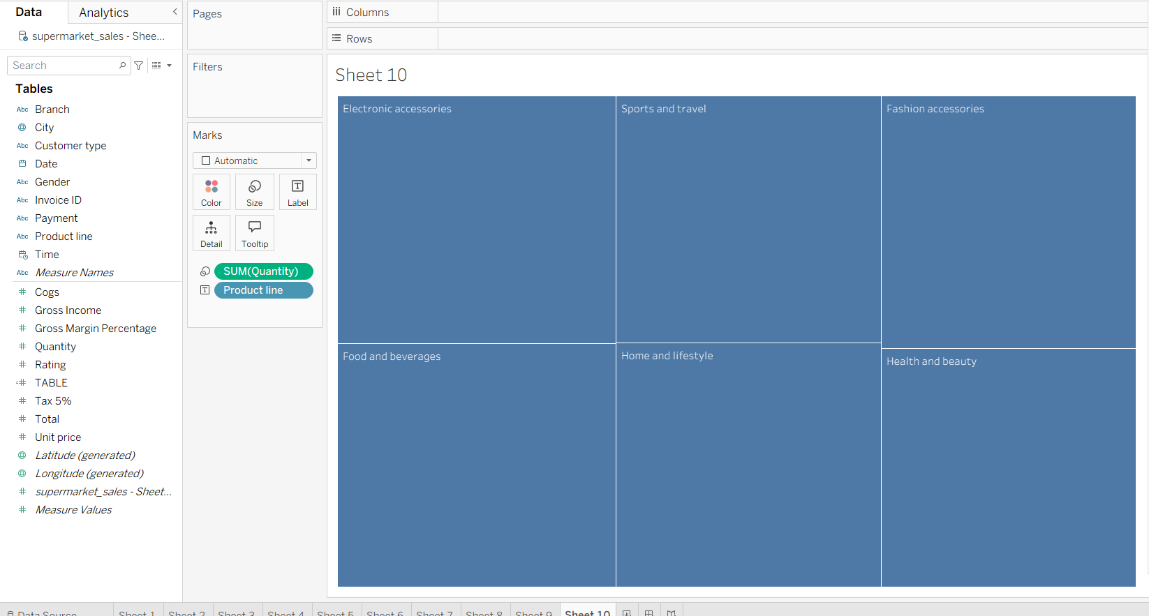

6.FUNNEL CHART:

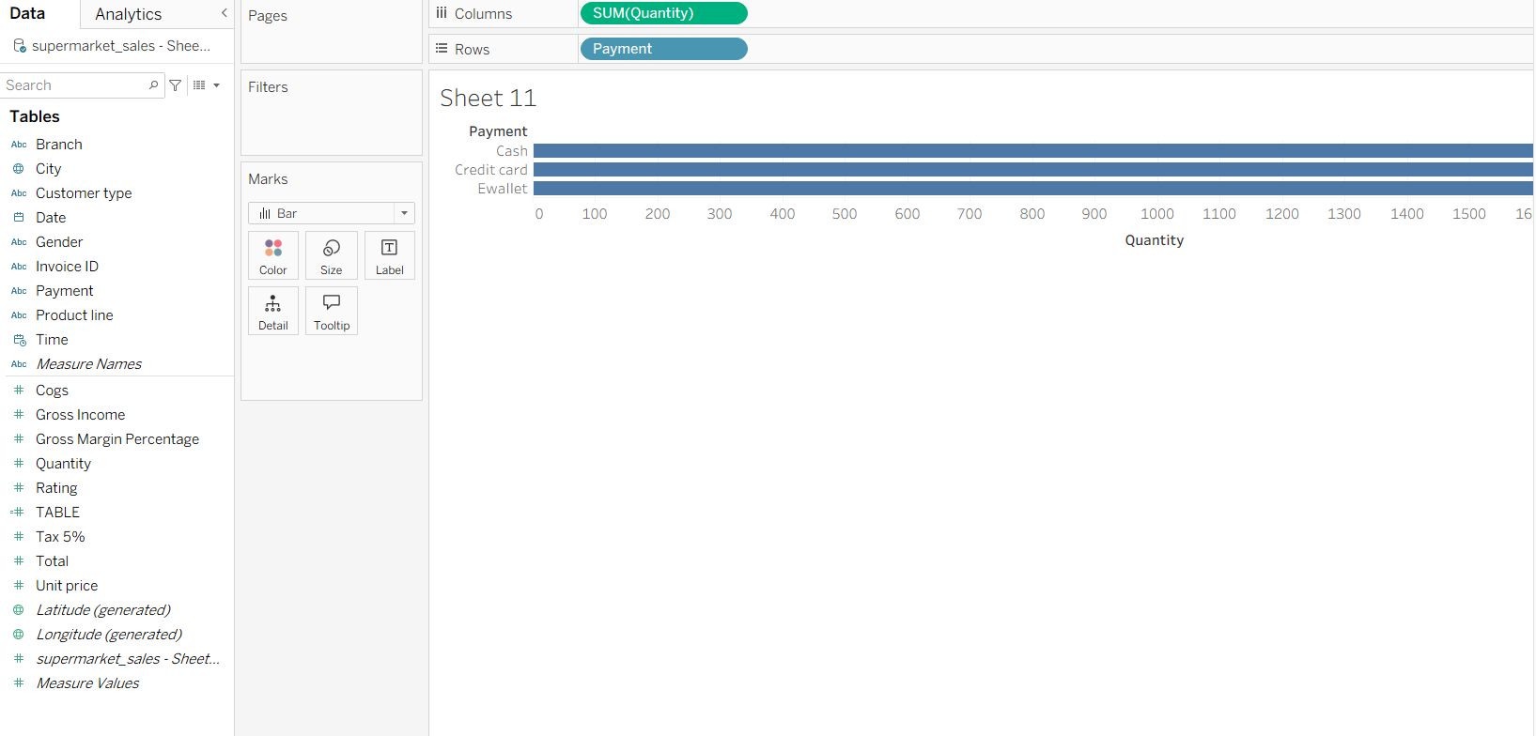

6.WATERFALL CHART:  
